**10 Days SQL Challenge**

**Challenge Day1**

Use the given data to Enlist all the Drivers, earning less than or equal to 20k or earning more than or equal to 50.

Query :

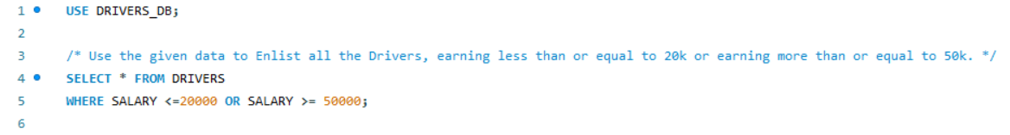

Output Table :

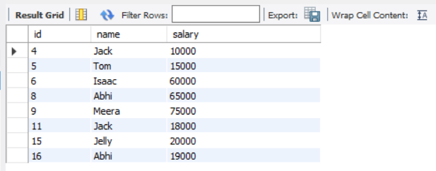

**Challenge Day 2**

Use the given Restaurants Datasets to find the cities with at least 2 Restaurants with 5 star Ratings.  
Your Output table should contain the city name along with number of 5 star restaurants in that city.  
Order the records in Descending order of No. of Restaurants and in case of tie , sort them in alphabetical order.

Query:

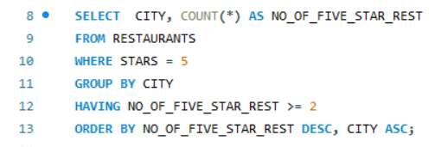

Output Table:

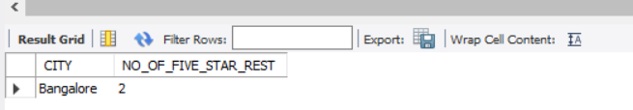

**Challenge Day 3**

Use the given House Dataset to find the Top 3 Postal Codes for each year with Average Price of that Postal Code as the Ranking criteria.

Query:

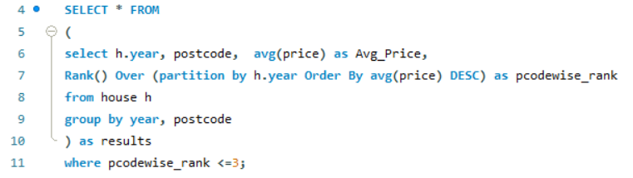

Output Table:

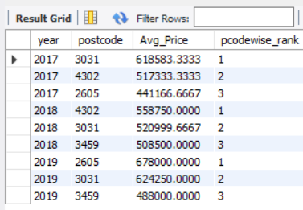

**Challenge Day 4**

(Got this query wrong.)

Use the given data to enlist the employees who have received raise in their salary for at least 3 consecutive years.

Query :

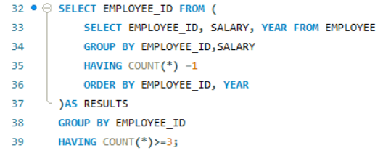

Output Table :

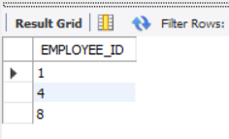

**Challenge Day 5**

In the following dataset 1-2,3-4,5-6,7-8 form a pair but the class teacher decides to interchange the students ids of each pair. Help the teacher to write a SQL query to interchange all the pair id in one go.

Input Query:

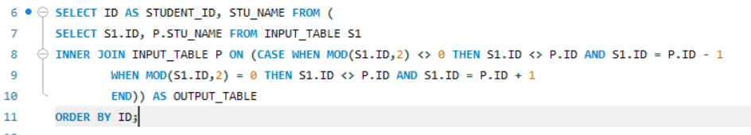

Output Table:

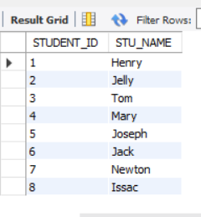

**Challenge Day 6**

You’re given a table of rental property searches by users.  
  
 The table consists of search results and outputs host information for searchers.   
 Find the minimum, average, maximum rental prices for each host’s popularity rating.  
 The host’s popularity rating is defined as below:  
    0 reviews: New  
    1 to 5 reviews: Rising  
    6 to 15 reviews: Trending Up  
    16 to 40 reviews: Popular  
    more than 40 reviews: Hot  
Tip: The `id` column in the table refers to the search ID.

Query for problem statement:

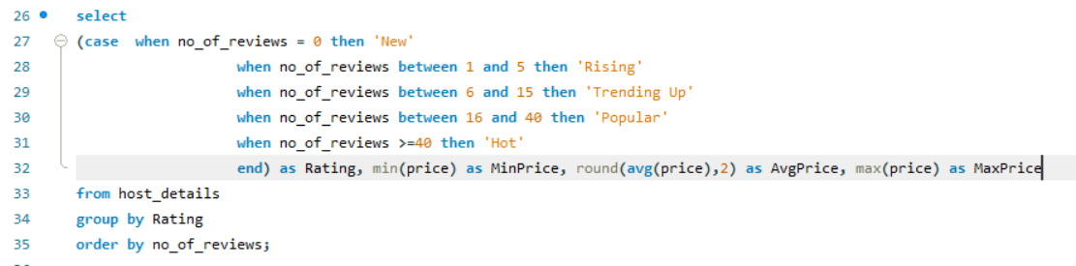

Output Table:

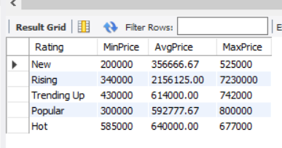

Had also converted host_since from string to date format as part of data cleaning. (Ignore if not required)

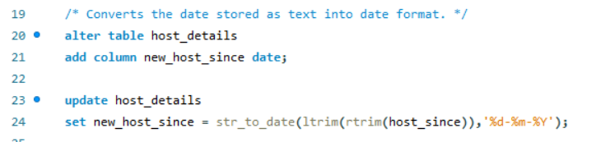

**Challenge Day 7**

Use the given data to find the customer with the highest total order cost within a single day  between   
2021-02-01 to 2021-03-01.Total order cost is calculated as order_cost*order_quantity.   
Output their first name, total sales amount and the date.   
For simplicity, you can assume that every first name in the dataset is unique. Also, the cost of the certain item   
(e.g. shoes) could vary among different purchases (not all shoes cost the same).*/

Query:

Query for converting date from text to date format:

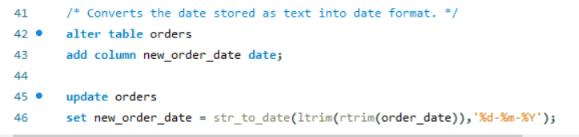

Query for selecting output:

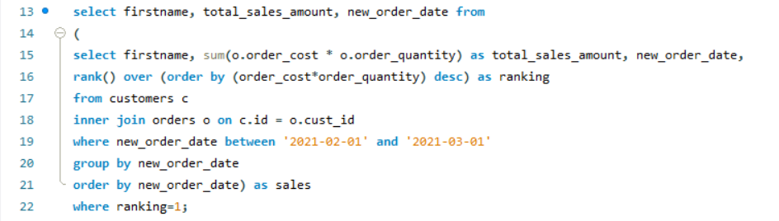

Output Table:

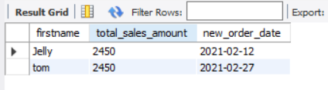

**Challenge Day 8**

Use the given data to find the total number of downloads for paying and non-paying users by date.   
  
Include only records where non-paying customers have more downloads than   
paying customers. The output should be sorted by earliest date first and contain 3 columns   
date, non-paying downloads, paying downloads.

Query:

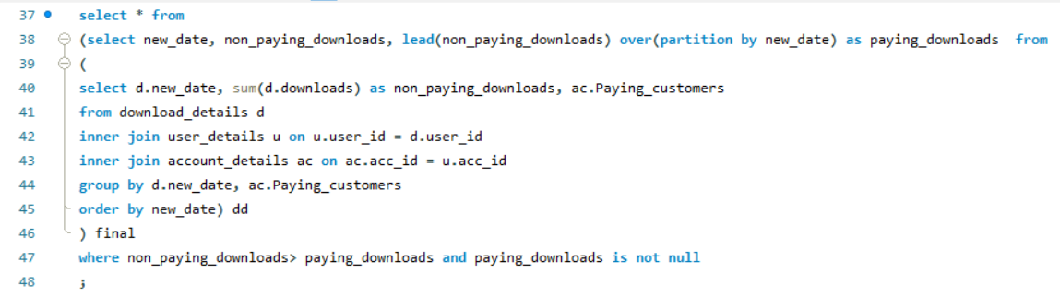

Output Table:

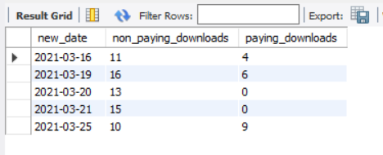

**Challenge Day 9**

Use the given data to find the popularity percentage for each user on Facebook.   
The popularity percentage is defined as the total number of friends   
the user has divided by the total number of users on the platform,  
 then converted into a percentage by multiplying by 100.   
 Output each user along with their popularity percentage.   
 Order records in ascending order by user id.   
 The 'user1' and 'user2' column are pairs of friends.

Query:

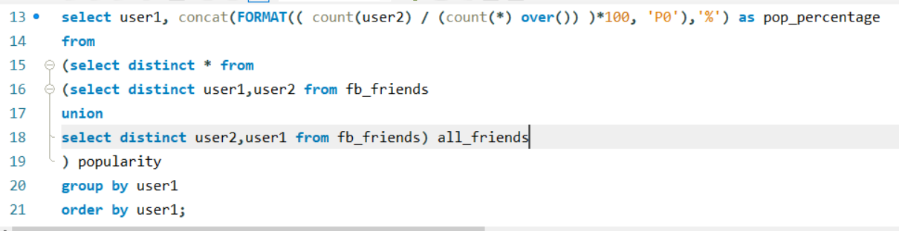

Output Table:

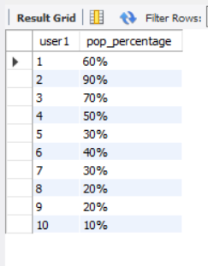

**Challenge Day 10**

Marketing_Campaign data  
You have a table of in-app purchases by user. Users that make their  
 first in-app purchase are placed in a marketing campaign where they see   
 call-to-actions for more in-app purchases of products . Find the number of users that  
 made additional in-app purchases due to  the marketing campaign.  
  
The marketing campaign doesn't start until one day after the initial  
 in-app purchase so users that make multiple purchases on  
 the same day do not count, nor do we count users that  
 make only the same purchases over time.

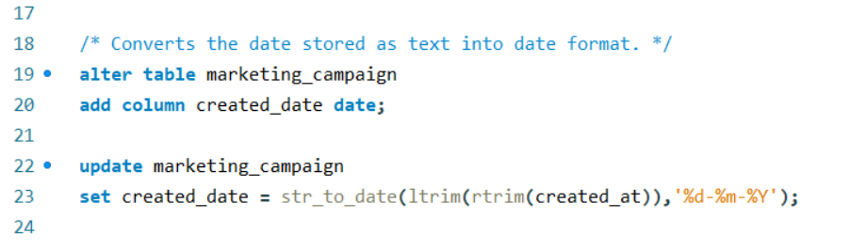

Problem Statement:  Find the number of users that  
 made additional in-app purchases due to the marketing campaign.*/

(Assuming we have to output only the No. of users based on above problem statement.)

